DHT11 SENSOR
DHT11 is an embedded sensor, used to measure both temperature and humidity of the surroundings. It is made up of two different parts i.e. capacitive humidity sensor and a thermistor. DHT11 is a slow sensor but is quite efficient for the applications where we need to do some basic analog data exchange. There is a small chip inside this sensor which performs the function of analog to digital to analog conversion and gives the results for temperature as well as for humidity in digital form. This digital signal can be read easily through any micro-controller.
DHT11 is a low cost sensor and is easily available in the market now a days. This property makes it more popular among the similar type of sensors. It provide precise results with the higher efficiency. It has a small size and low power consumption. It can transmit the signal up to 20 meters. It has four pins whose detail will be explained later. DHT11 has a lot of features including low cost, long term stability, fast response time, excellent quality, long distance signal transmission and many more. In real life DHT11 can be used at several different places e.g. home appliances, weather stations, consumer goods etc.
- DHT11 is an electronic sensor, consists of 4 pins and is used to measure the temperature and humidity of the surroundings.
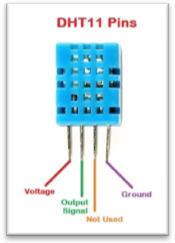
DHT Pinout is as follows:
  - Pin#1: Vcc (+5V)
  - Pin#2: Out (digital)
  - Pin#3: NC (Not Connected)
  - Pin#4: GND (Ground)
It has both a capacitive humidity sensor and a thermistor embedded in it. It is a low-cost sensor but provides precise results and it gives value once every 2 seconds. DHT11 measures the relative humidity of the surrounding. It is used in home appliances, weather stations, medical humidity control, data loggers, HVAC and at several security places.

DHT11 Working Principle
- In order to measure temperature, DHT11 uses a thermistor also known as NTC (Negative Temperature Coefficient) temperature sensor.
- A thermistor is simply a variable resistor, which changes its resistance with respect to the temperature.
- A thermistor is made up of sintering of semiconductors in order to provide a large change in its resistance with the small changes in temperature.
- NTC means the resistance decrease with the increase in temperature.
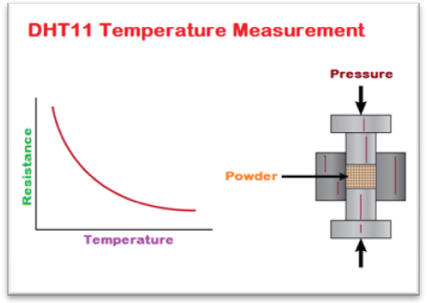
- For humidity sensing, DHT11 uses a capacitive humidity sensor.
- The humidity part consists of two electrodes having moisture-holding substrates in between them.
- As the humidity level changes, the resistance between both of the electrodes or conductivity also changes correspondingly.
- This change in conductivity or resistance is estimated and processed by an internal IC.
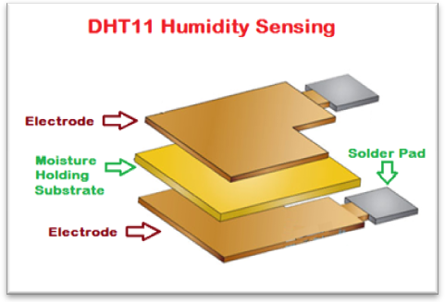

DHT11 Temperature Sensing Characteristics
- The temperature sensing characteristics of the DHT11 sensor are listed in the below table:
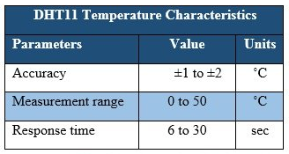

DHT11 Humidity Sensing Characteristics
- The humidity sensing characteristics of the DHT11 sensor are listed in the below table: